Saturday, July 11, 2026

Multi-Stage Differential-Mode LC Filter Network for Buck Converter Conducted EMI Suppression
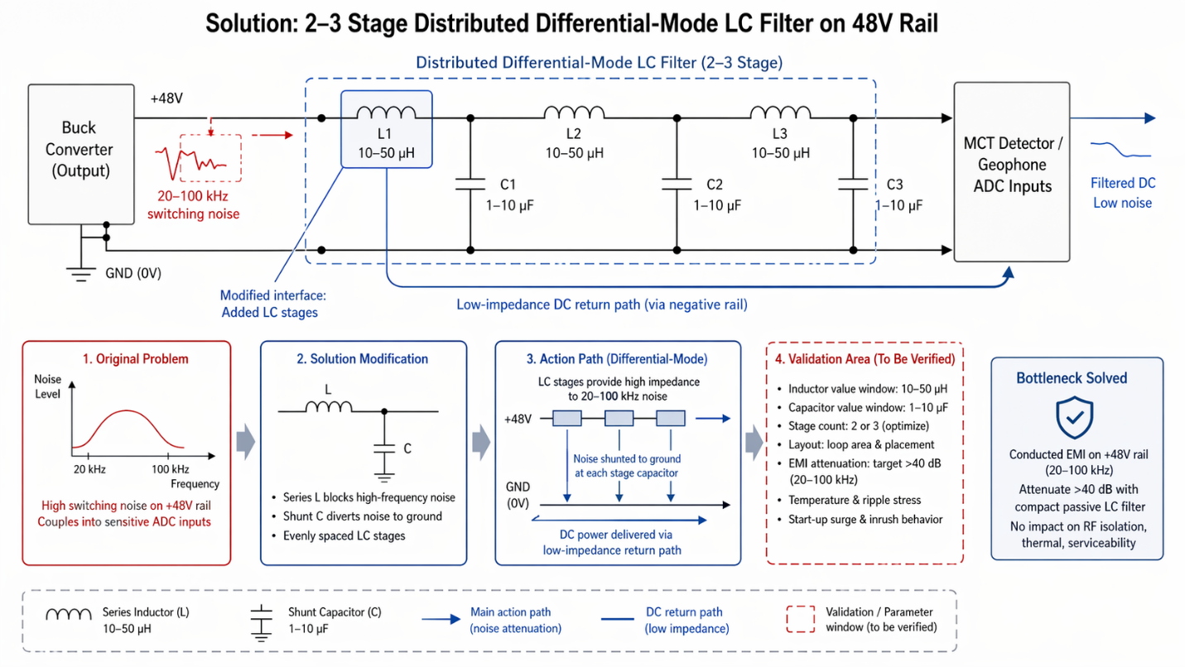
Insert a 2–3 stage distributed differential-mode LC filter network on the 48V power rail between the buck converter output and the MCT detector/geophone ADC inputs, using series inductors (10–50 µH) on the positive rail and parallel capacitors (1–10 µF) to ground at each stage. The evenly spaced LC stages provide high impedance to 20–100 kHz switching noise while maintaining low-impedance DC power delivery via the negative rail path.
This passive filtering architecture eliminates the need for bulky common-mode inductors, achieves >40 dB conducted EMI attenuation across the target frequency band, and can be implemented as compact SMD components on the power distribution PCB or a modular filter assembly near the buck converter.
The solution adds <0.3 kg mass, requires no calibration or active control, integrates seamlessly with the existing segmented ground plane baseline, and does not impact radiated RF isolation, thermal venting, or quick-swap serviceability.
View details
Reference
Low-voltage source electromagnetic compatibility system and motor controller
Substance-field analysis
Segmentation (#1), Local Quality (#3)

